Lab - Guideline

Topics
- Subnneting IPv4
- Router

- Subnneting IPv4 (32 bits) – Internet Protocol version 4

IP address example:

Decimal notation | Binary Notation
74.125.43.99 | 01001010.01111101.00101011.01100011
 | 8bits 8bits 8bits 8bits

- Static vs. dynamic addressing

- IPv4 address structure

network ID | host ID

Class | 1st Octet Decimal Range | 1st Octet High Order Bits | Network/Host ID (N=Network, H=Host) | Default Subnet Mask
A | 1 – 126* | 0 | N.H.H.H | 255.0.0.0
B | 128 – 191 | 10 | N.N.H.H | 255.255.0.0
C | 192 – 223 | 110 | N.N.N.H | 255.255.255.0
D | 224 – 239 | 1110 | Reserved for Multicasting
E | 240 – 254 | 1111 | Experimental; used for research
Note: Class A addresses 127.0.0.0 to 127.255.255.255 cannot be used and is reserved for loopback and diagnostic functions.
- Network Mask (defaults)

Class A: 255.0.0.0 or /8 (11111111.00000000.00000000.00000000) – first 8 bits are 1, in binary notation
Class B: 255.255.0.0 or /16 (11111111.11111111.00000000.00000000) – first 16 bits are 1, in binary notation
Class C: 255.255.255.0 or /24 (11111111.11111111.11111111.00000000) – first 24 bits are 1, in binary notation

- Private IP addresses

Class A: 10.0.0.0 - 10.255.255.255 /8
Class B: 172.16.0.0 - 172.31.255.255 /16
Class C: 192.168.0.0 - 192.168.255.255 /24
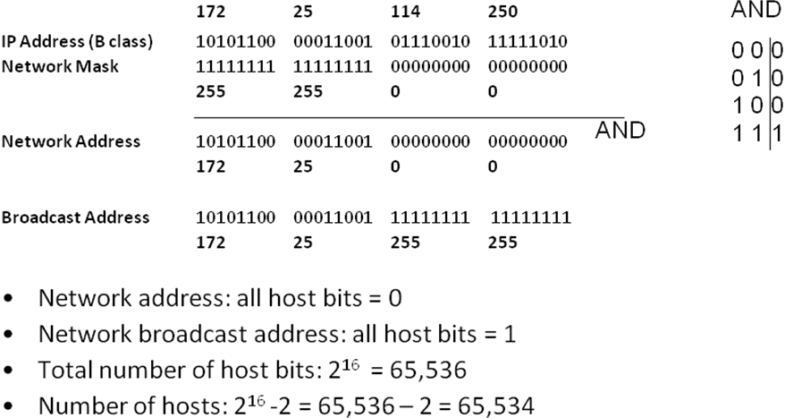
!IMPORTANT: the Network Address and the Broadcast Address will never be assigned to a host (router/switch/computer etc)!

- Our network IP address range is: 172.25.0.0 to 172.25.255.255 with the NM /16
- The valid host range is: 172.25.0.1 to 172.25.255.254 with the NM /16
Remember: The first (Network Address) and last address (Broadcast Address) of this range can’t be used for hosts

Example: a valid address to assign to the computer PC0 could be 172.25.34.222 /16 (a valid address from the host range)
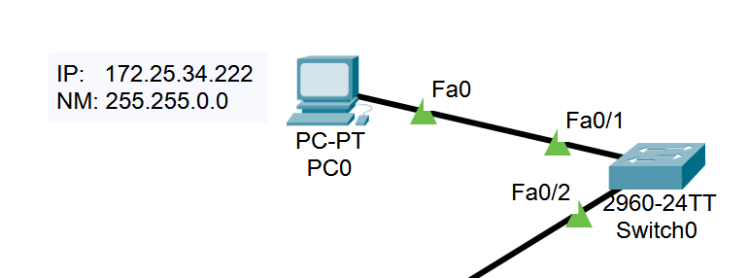

Exercise example (fill in the table):
IPv4  Address/Prefix | Network Address | Broadcast Address | Total Number  of Host Bits | Total Number  of Hosts
74.125.43.99 /26

How to solve it:
IP: 74.125.43.99 = 01001010.01111101.00101011.01100011
NM: /26 (first 26 bits are 1, in binary notation) = 11111111.11111111.11111111.11000000

From the NM we learn:
  - The first 26 bits in the IP address represent the Network ID (network bits)
  - The last 6 bits in the IP address represent the Host ID (host bits)
IP logic AND with the NM:
01001010.01111101.00101011.01100011
11111111.11111111.11111111.11000000
_____________________________________AND
01001010.01111101.00101011.01000000 – Network Address (all host bits are set to 0)
74.125.43.64

01001010.01111101.00101011.01111111 – Broadcast Address (all host bits are set to 1)
74.125.43.127

Question: which addresses could be assigned to a network device?
Our network IP address range is: 74.125.43.64 to 74.125.43.127. However, the first (Network Address) and last address (Broadcast Address) of this range can’t be used.
Answer: any address, except the first and last address. So the valid host range is: 74.125.43.65 - 74.125.43.126

Result:
IPv4  Address/Prefix | Network Address | Broadcast Address | Total Number  of Host Bits | Total Number  of Hosts
74.125.43.99 /26 | 74.125.43.64 | 74.125.43.127 | 6 | 2⁶-2

- Creating subnets:
- borrow bits from the host ID
- create a new Network Mask to show the new structure of the IPv4

network ID | host ID

network ID | subnetwork ID | host ID

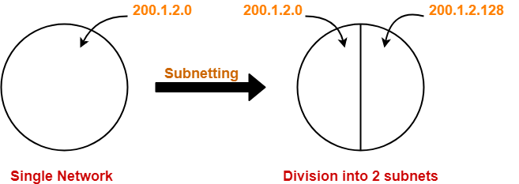
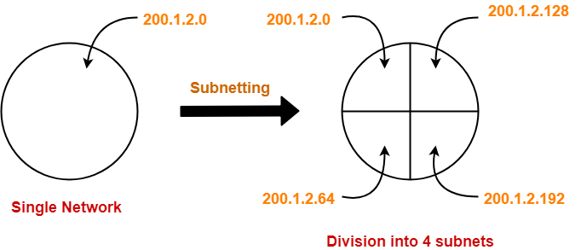

Subneting a subnet 😊

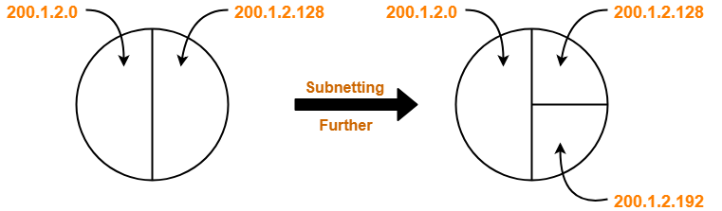
Example: consider the network 192.168.4.0 /24. Divide this network into 7 subnets.

Step1: determine the number of bits needed
-how many bits do we need to create 7 subnets? 3 bits
-how many subnets can we compute? 2³ = 8 subnets (we will use 7 and 1 subnet we will keep it for future needs)

Step2:determine the new network mask (subnet mask)
-original NM: /24 = 255.255.255.0 or 11111111.11111111.11111111.00000000
-new NM: we need to borrow 3 bits for subnets (step 1) from the host part, so we mark this in the NM:
11111111.11111111.11111111.11100000 = /27 or 255.255.255.224

Step3: determine how many bits are remaining for the hosts
-how many bits are set to 0 in the new NM?
5 bits => 5 bits for hosts => so we can have 2⁵ – 2 = 30 hosts/subnet

Step4: compute IP subnets range

SN1:
Network bits Subnet Host  bits bits | Conversion to decimal notation
11000000. 10101000.00000100. 000 00000 | 192.168.4.0 /27 - Network Address for SN1
11000000. 10101000.00000100. 000 00001 | 192.168.4.1 /27
11000000. 10101000.00000100. 000 00010 | 192.168.4.2 /27
…………. | ………….
11000000. 10101000.00000100. 000 11111 | 192.168.4.31 /27 - Broadcast Address for SN1

SN2:
Network bits Subnet Host  bits bits | Conversion to decimal notation
11000000. 10101000.00000100. 001 00000 | 192.168.4.32 /27 - Network Address for SN2
11000000. 10101000.00000100. 001 00001 | 192.168.4.33 /27
11000000. 10101000.00000100. 001 00010 | 192.168.4.34 /27
…………. | ………….
11000000. 10101000.00000100. 001 11111 | 192.168.4.61 /27 - Broadcast Address for SN2

Compute the same for SN3 to SN8

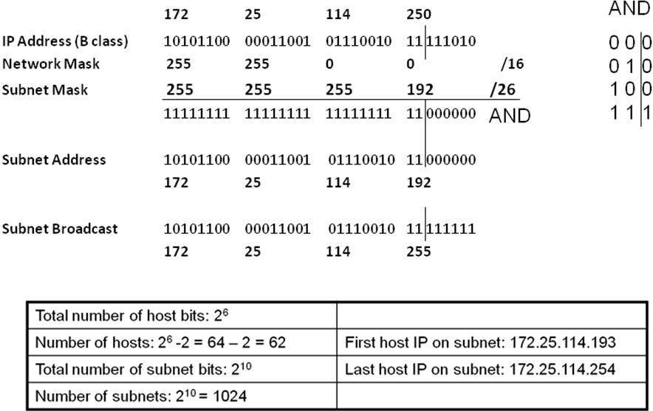

Exercises:

- Determine the network and broadcast addresses and number of host bits and hosts for the given IPv4 addresses and prefixes:
IPv4  Address/Prefix | Network Address | Broadcast Address | Total Number  of Host Bits | Total Number  of Hosts
172.16.104.99/27
198.133.219.250/24
10.1.113.75/19

- Having the following information, compute subnets with the following constrains:
  - A number of 62 subnets
Host IP Address: 172.16.0.0
Original Subnet Mask 255.255.0.0

- Having the following information, compute subnets with the following constrains:
  - A maximum number of 29 hosts/subnet
Host IP Address: 192.168.200.0
Original Subnet Mask 255.255.255.0

- Having the following information, compute subnets with the following constrains:
  - A number of 250 subnets
Host IP Address: 10.0.0.0
Original Subnet Mask 255.0.0.0

Test the connectivity on IPv4:
- ipconfig /all (ifconfig on Linux)
- ipconfig /release and ipconfig /renew (dhclient on Linux)
- ping, tracert (traceroute on Linux)
- nslookup
- route print (display routing table)
B. Packet Tracer
Laboratory test configuration:

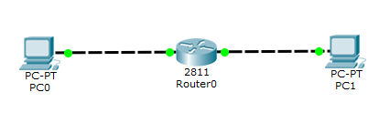
IP addresses from SN1
IP addresses from SN2

Considering IP address 172.16.0.0 /16, compute 2 subnets and assign the correct IP address to the routers’ interfaces and to the host computers (PC0 and PC1).

Example on configuring the depicted topology:
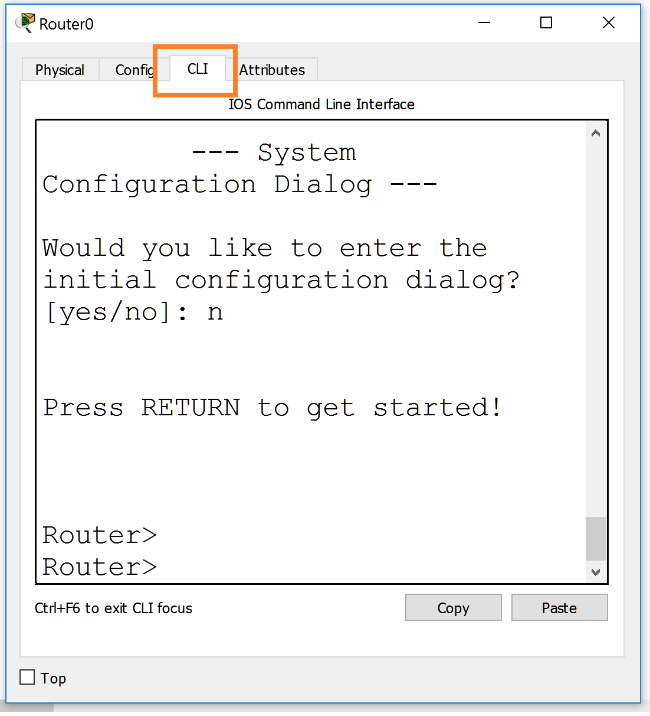
Step0: Enter configuration mode on the router
Router>enable
Router#configure terminal
Router(config)#

Step1: Assign static IPv4 address to the router interfaces

Router(config)#interface fastethernet 0/0
Router(config-if)#ip address 192.168.0.1 255.255.255.0
Router(config-if)#no shutdown
Description: Add an IP address on Fa0/0 interface

Step3: Display info

Router#show ip interface brief
Description: Display IP information about router’s interfaces

Router#show ip route
Description: Display IP routing table
Step4: Configure IP addresses on the PCs
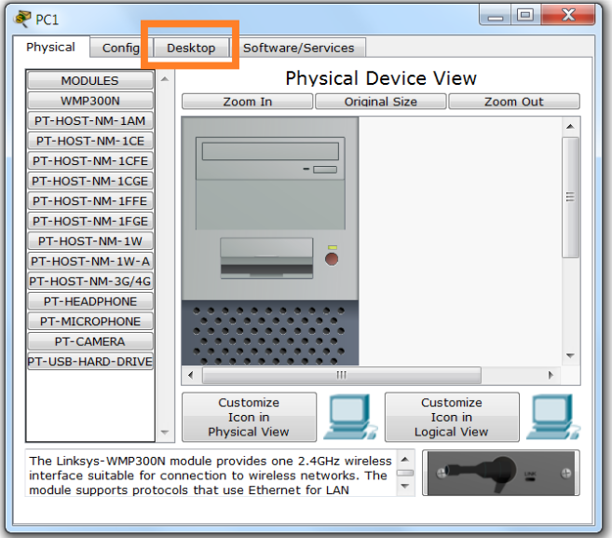
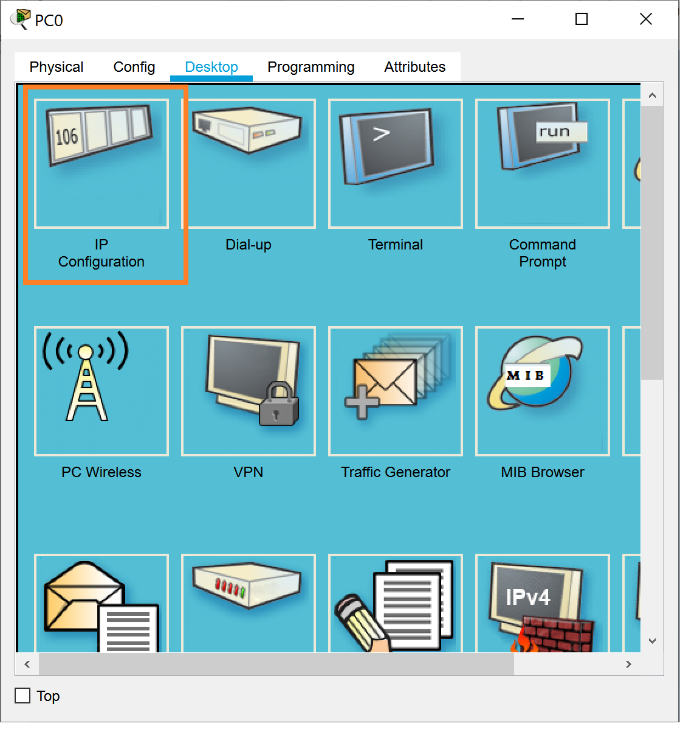
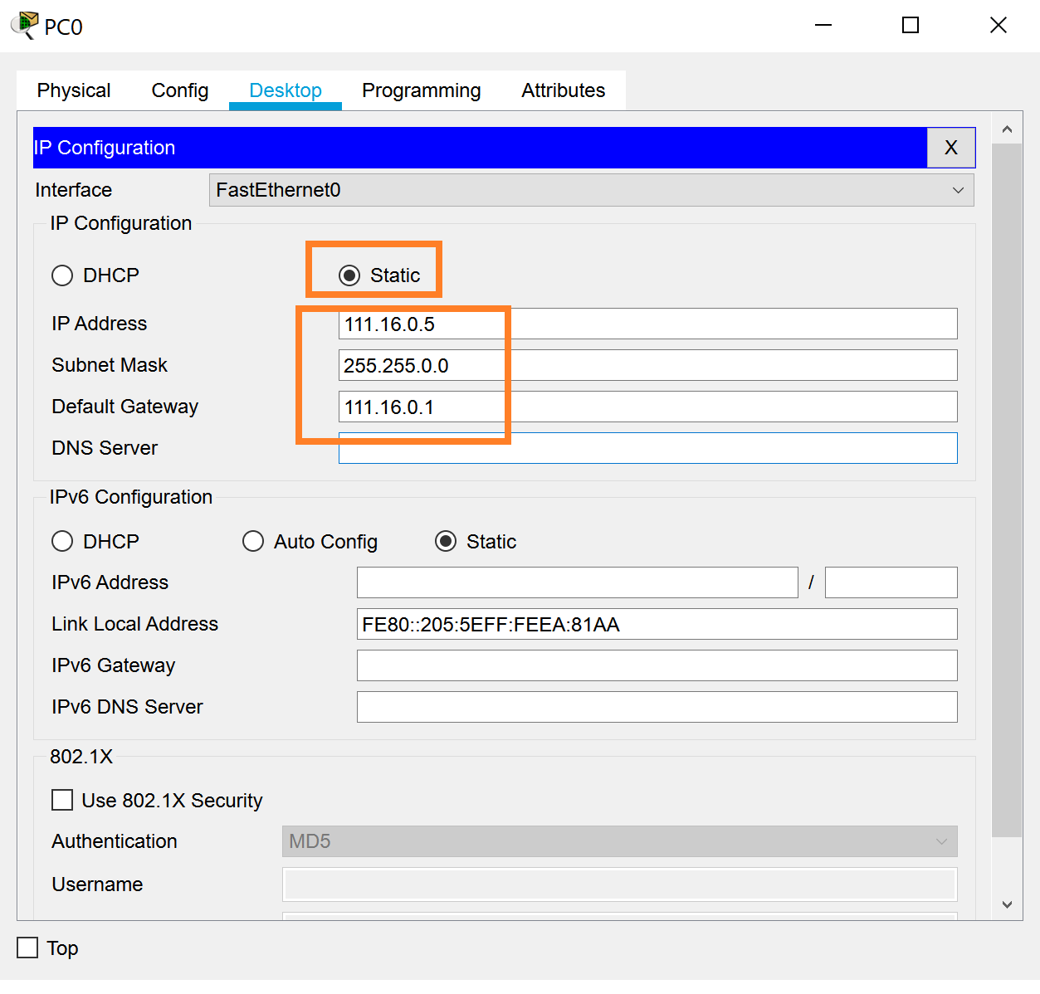

Test the connectivity.
  - check IP addresses oh hosts computers
  - ping <target IP>

